**SQL QUERIES TASK**

# **SQL Lesson 1: SELECT queries 101**

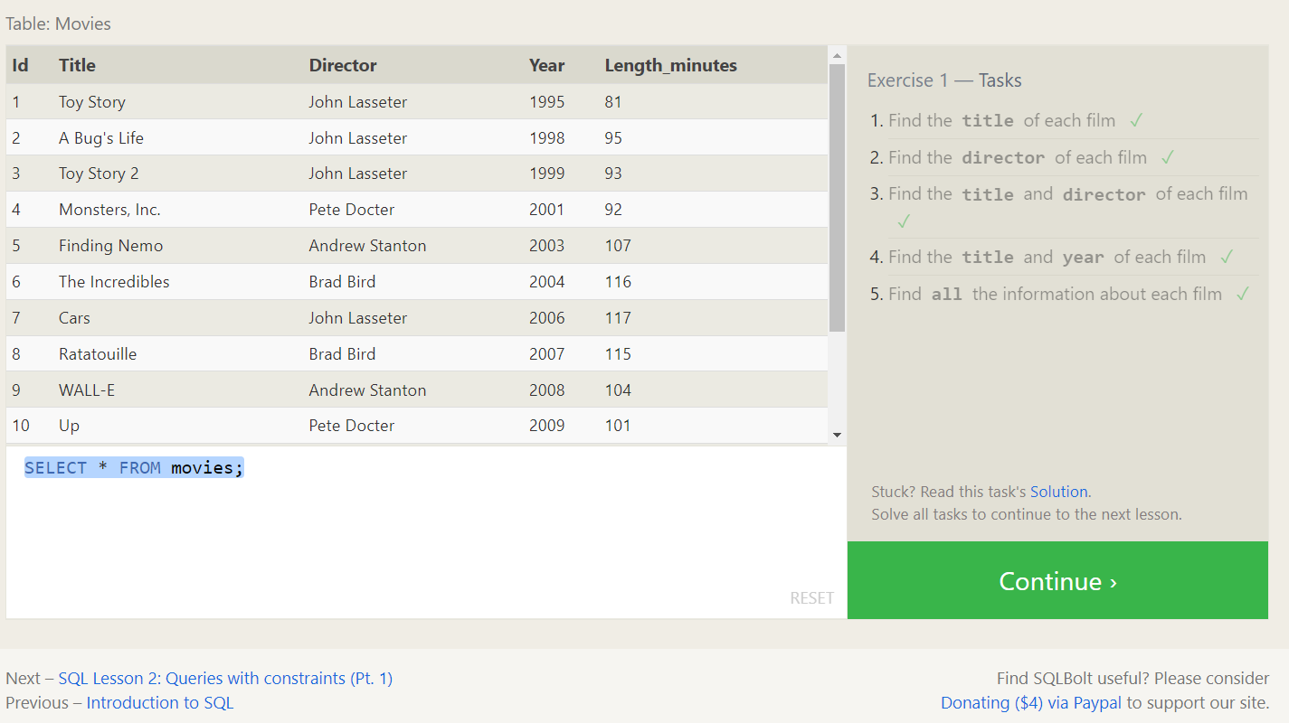

**1.SELECT title FROM movies;**

**2.SELECT director FROM movies;**

**3.SELECT title,director FROM movies;**

**4.SELECT title,year FROM movies;**

**5.SELECT * FROM movies;**

# **SQL Lesson 2: Queries with constraints**

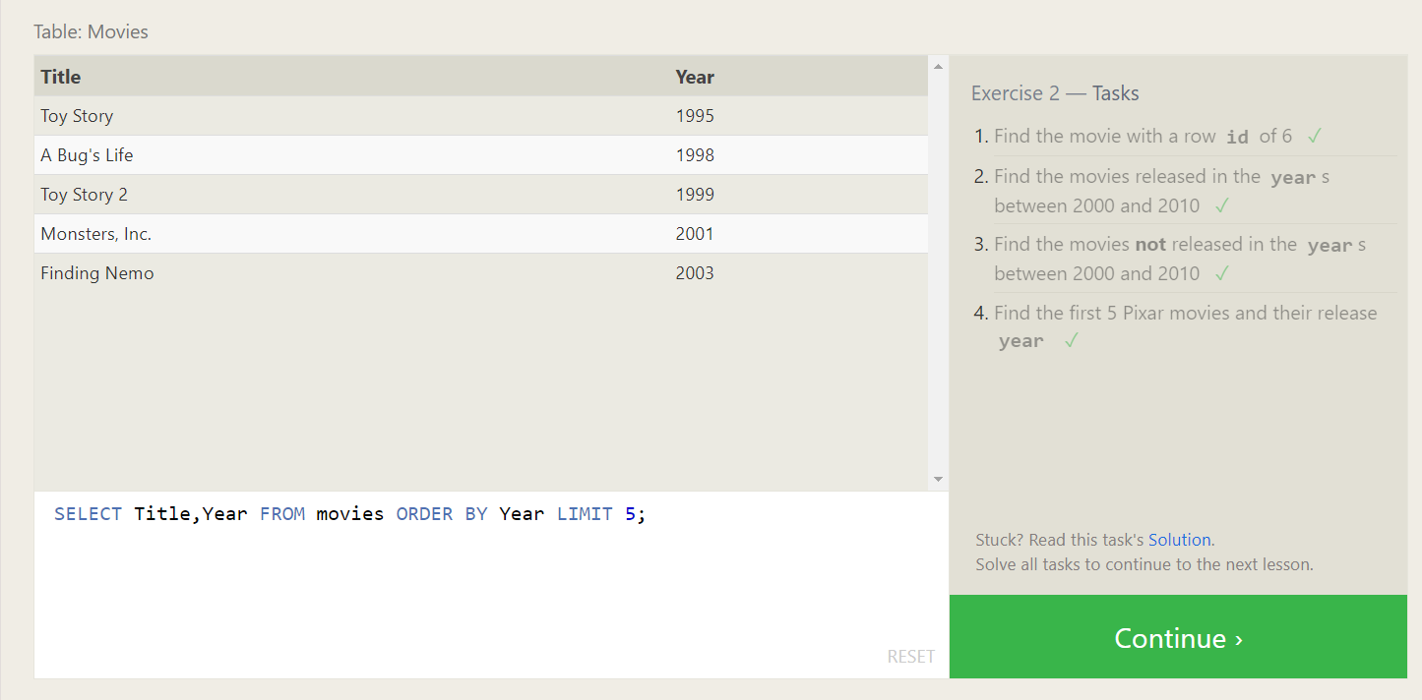

**1.SELECT * FROM movies where id is 6**

**2.SELECT * FROM movies WHERE Year BETWEEN 2000 AND 2010;**

**3.SELECT * FROM movies WHERE Year NOT BETWEEN 2000 AND 2010;**

**4.SELECT Title,Year FROM movies ORDER BY Year LIMIT 5;**

# **SQL Lesson 3: Queries with constraints**

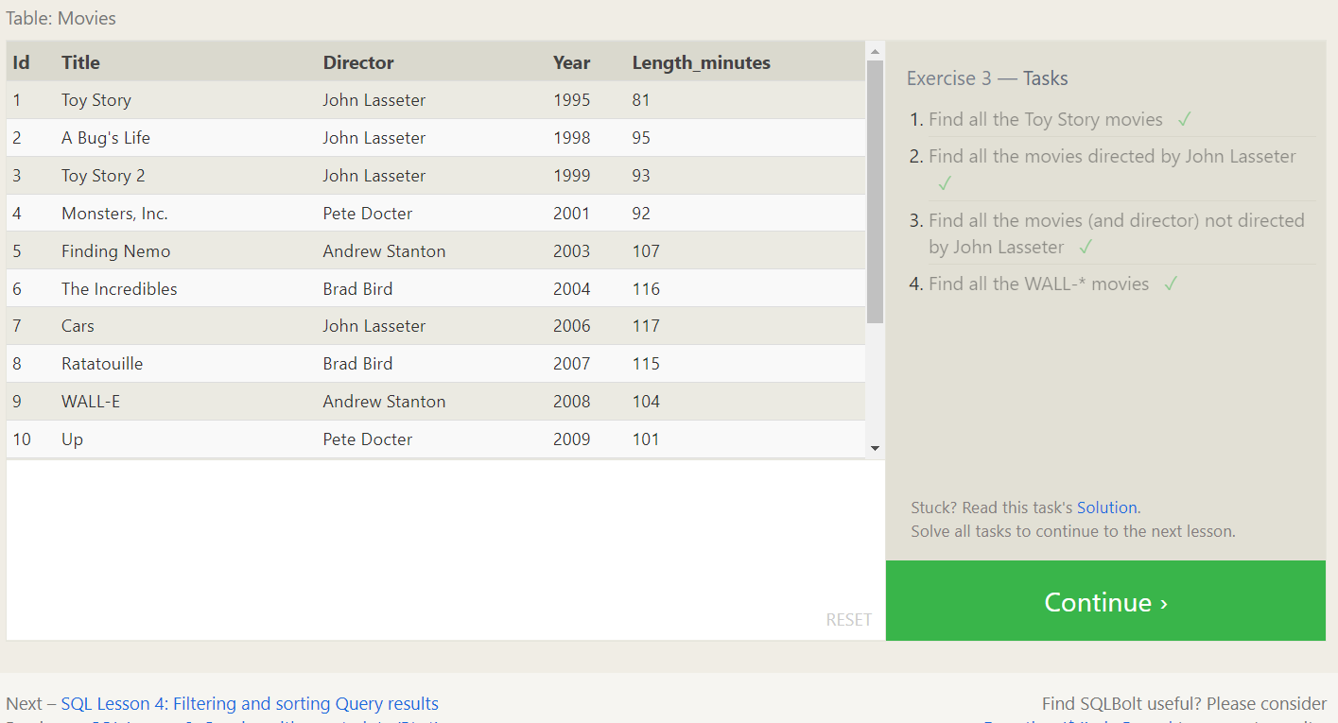

**1.SELECT * FROM movies WHERE Title LIKE 'Toy Story%';**

**2.SELECT * FROM movies WHERE Director = 'John Lasseter';**

**3.SELECT * FROM movies WHERE Director <> 'John Lasseter';**

**4.SELECT * FROM movies WHERE Title LIKE 'WALL-%';**

# **SQL Lesson 4: Filtering and sorting Query results**

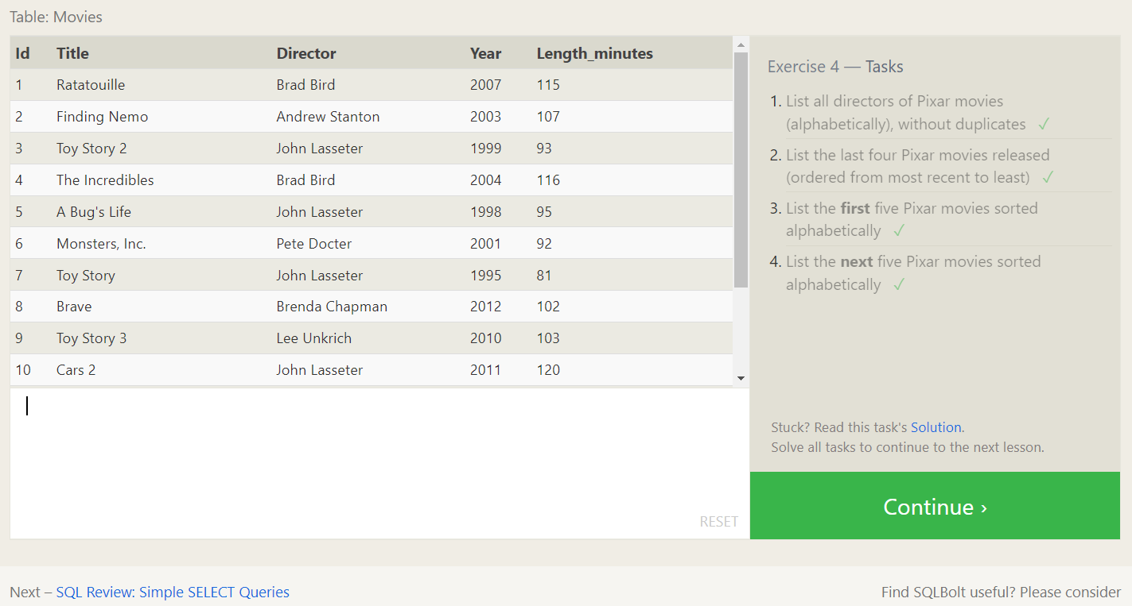

**1.SELECT DISTINCT Director FROM movies ORDER BY Director;**

**2.SELECT * FROM movies ORDER BY Year DESC LIMIT 4;**

**3.SELECT * FROM movies ORDER BY Title LIMIT 5;**

**4.SELECT * FROM movies ORDER BY Title LIMIT 5 OFFSET 5;**

# **SQL Review: Simple SELECT Queries**

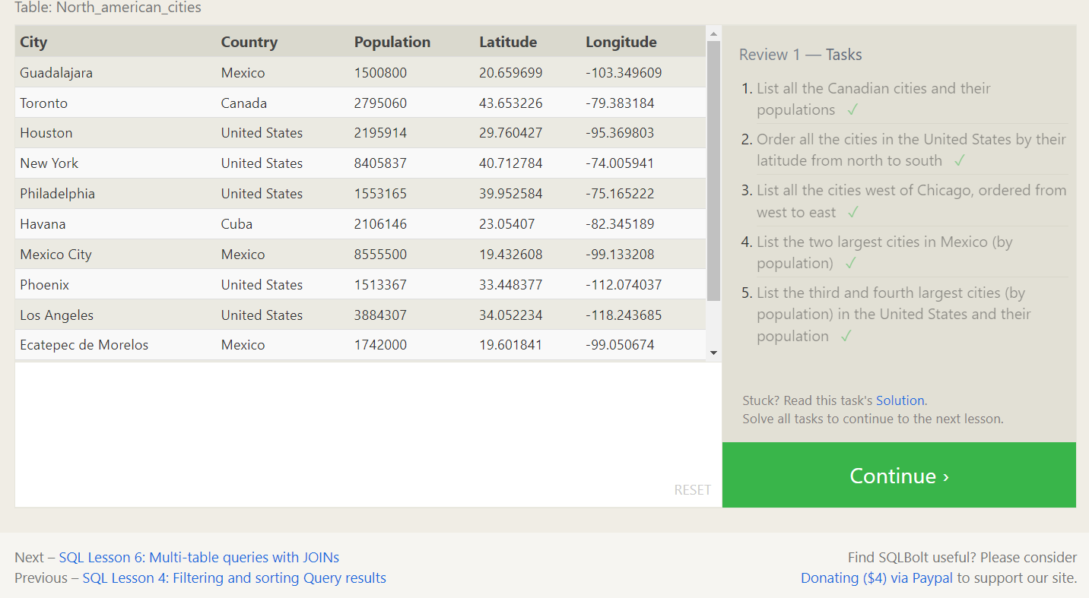

**1.SELECT City,population FROM North_american_cities WHERE country = 'Canada';**

**2.SELECT City, Latitude FROM North_american_cities**

**WHERE Country = 'United States'**

**ORDER BY Latitude DESC;**

**3.SELECT City, Longitude FROM North_american_cities**

**WHERE Longitude < (SELECT Longitude FROM North_american_cities**

**WHERE City = 'Chicago') ORDER BY Longitude ASC;**

**4.SELECT City, Population FROM North_american_cities WHERE Country = 'Mexico'**

**ORDER BY Population DESC LIMIT 2;**

**5.SELECT City, Population FROM North_american_cities**

**WHERE Country = 'United States' ORDER BY Population DESC LIMIT 2 OFFSET 2;**

# **SQL Lesson 6: Multi-table queries with JOINs**

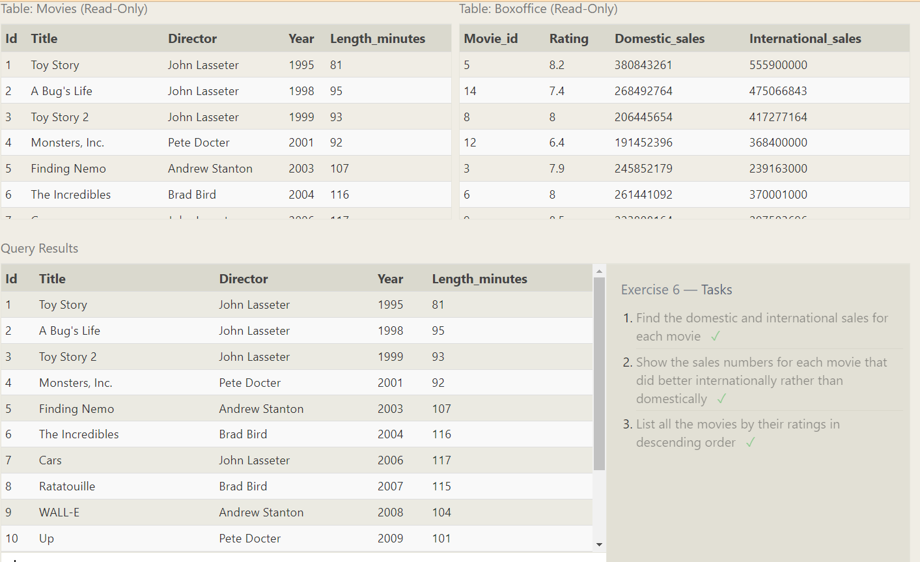

**1.SELECT m.Title, b.Domestic_sales, b.International_sales**

**FROM Movies m JOIN Boxoffice b ON m.Id = b.Movie_id;**

**2.SELECT m.Title, b.Domestic_sales, b.International_sales**

**FROM Movies m JOIN Boxoffice b ON m.Id = b.Movie_id**

**WHERE b.International_sales > b.Domestic_sales;**

**3.SELECT m.Title, b.Rating FROM Movies m JOIN Boxoffice b ON m.Id = b.Movie_id**

**ORDER BY b.Rating DESC;**

# **SQL Lesson 7: OUTER JOINs**

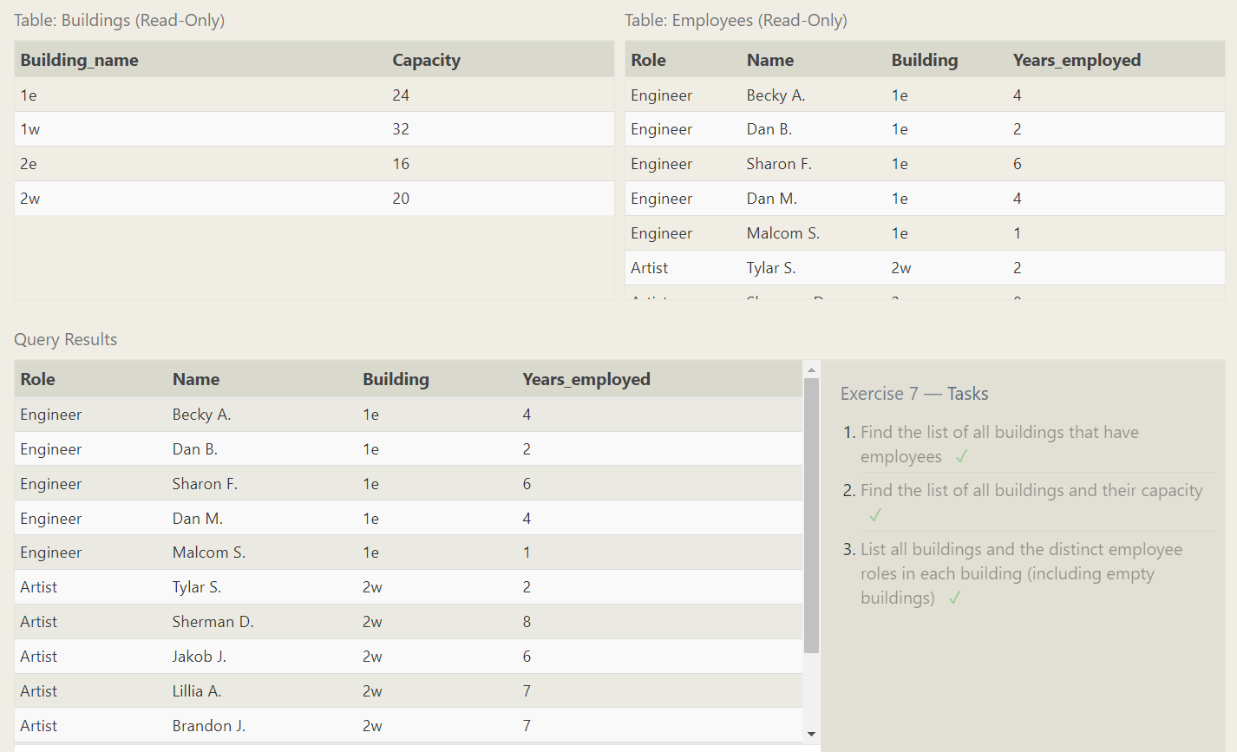

**1.SELECT DISTINCT Building FROM Employees;**

**2.SELECT Building_name, Capacity FROM Buildings;**

**3.SELECT DISTINCT building_name, role FROM buildings LEFT JOIN employees**

**ON building_name = building;**

# **SQL Lesson 8: A short note on NULLs**

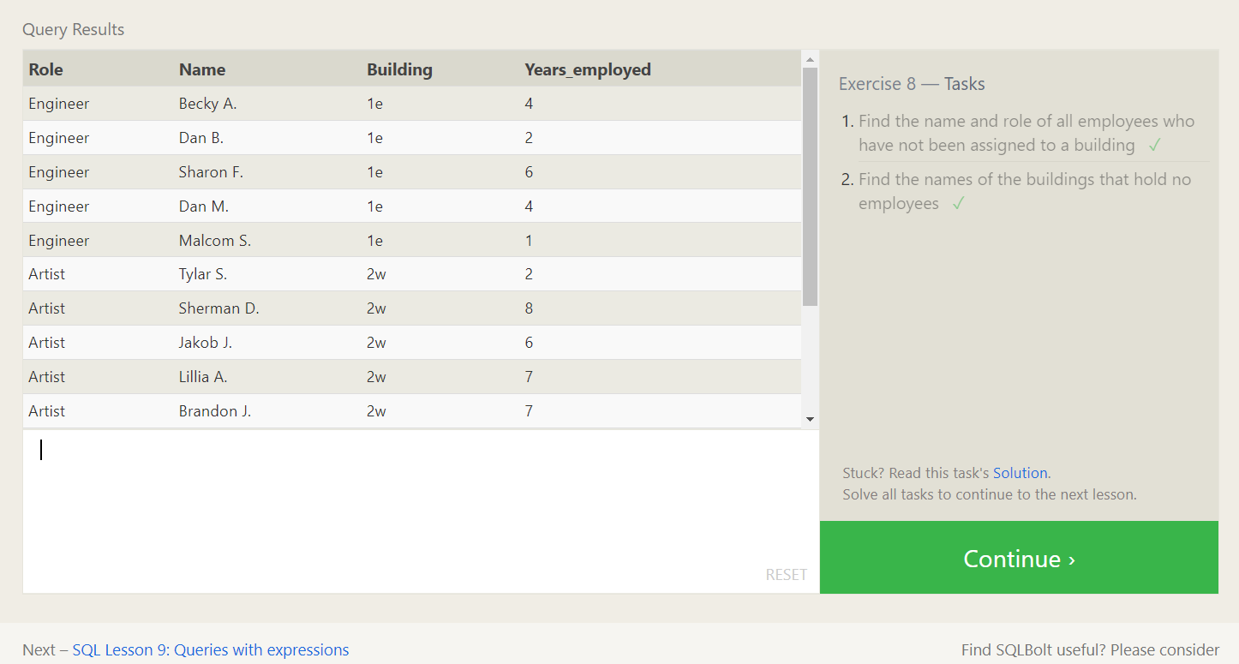

**1.SELECT Name, Role FROM Employees WHERE Building IS NULL;**

**2.SELECT Building_name FROM Buildings**

**WHERE Building_name NOT IN (SELECT DISTINCT Building FROM Employees**

**WHERE Building IS NOT NULL);**

# **SQL Lesson 9: Queries with expressions**

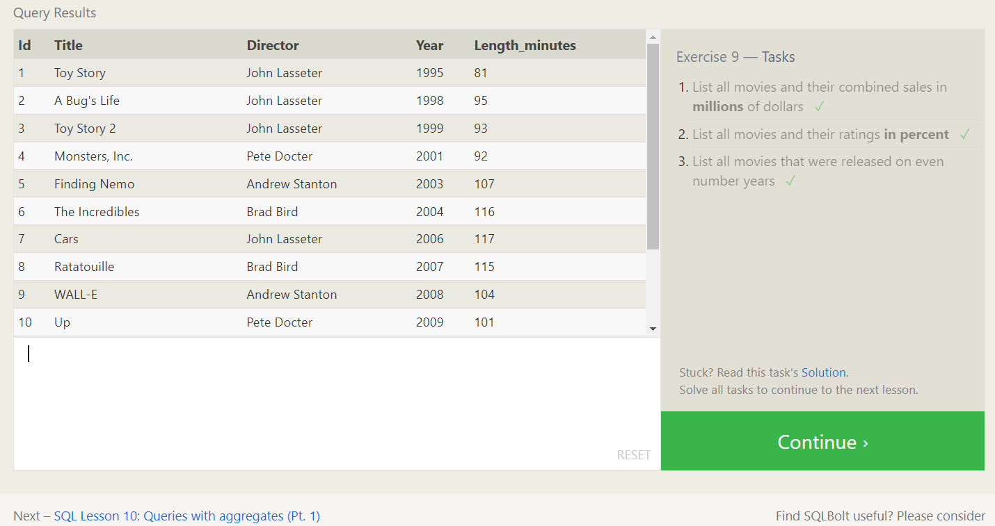

**1.SELECT m.Title, (b.Domestic_sales + b.International_sales) / 1000000 AS**

**Combined_sales FROM Movies m JOIN Boxoffice b ON m.Id = b.Movie_id;**

**2.SELECT title, rating * 10 AS rating_percent FROM movies JOIN boxoffice**

**ON movies.id = boxoffice.movie_id;**

**3.SELECT * FROM Movies WHERE Year % 2 = 0;**

# **SQL Lesson 10: Queries with aggregates (Pt. 1)**

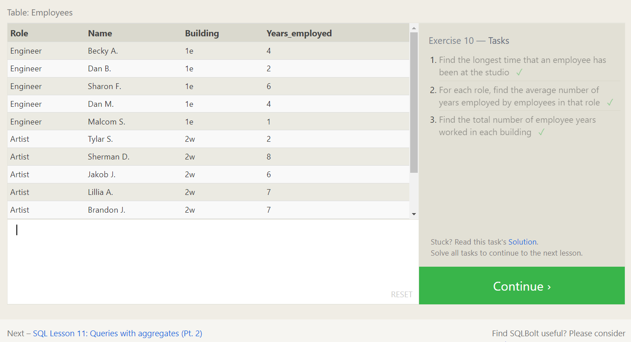

**1.SELECT MAX(Years_employed) AS Longest_time FROM Employees;**

**2.SELECT Role, AVG(Years_employed) AS Average_years FROM Employees**

**GROUP BY Role;**

**3.SELECT Building, SUM(Years_employed) AS Total_years_worked**

**FROM Employees GROUP BY Building;**

# **SQL Lesson 11: Queries with aggregates (Pt. 2)**

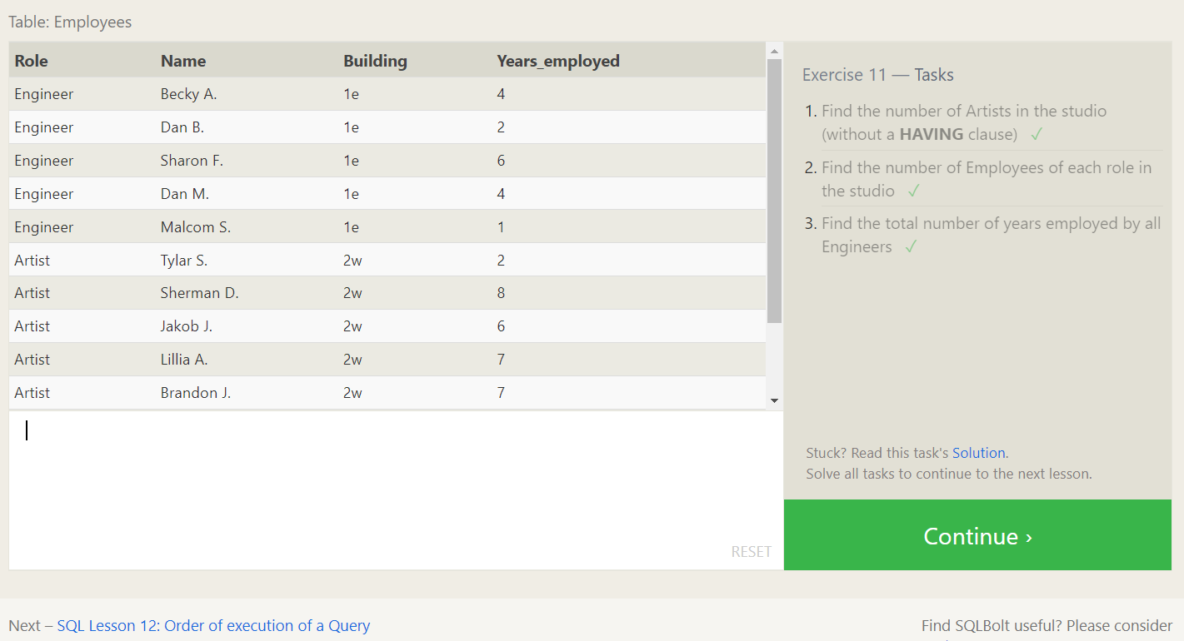

**1.SELECT COUNT(*) AS Number_of_Artists FROM Employees**

**WHERE Role = 'Artist';**

**2.SELECT Role, COUNT(*) AS Number_of_Employees FROM Employees**

**GROUP BY Role;**

**3.SELECT SUM(Years_employed) AS Total_Years_Employed FROM Employees**

**WHERE Role = 'Engineer';**

# **SQL Lesson 12: Order of execution of a Query**

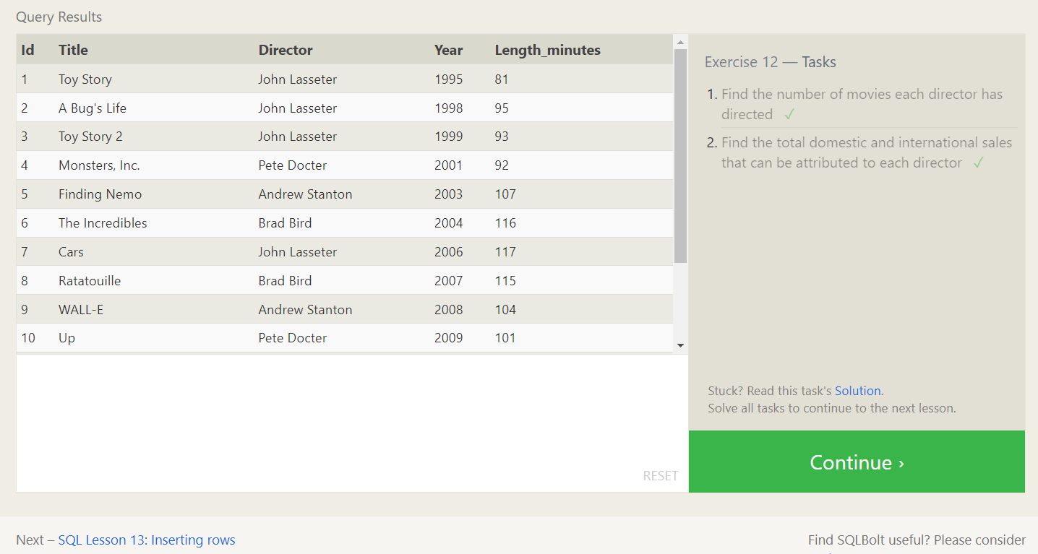

**1.SELECT Director, COUNT(*) AS Movies_Directed FROM Movies**

**GROUP BY Director;**

**2.SELECT director, SUM(domestic_sales + international_sales) as Cumulative_sales_from_all_movies FROM movies**

**INNER JOIN boxoffice ON movies.id = boxoffice.movie_id**

**GROUP BY director;**

# **SQL Lesson 13: Inserting rows**

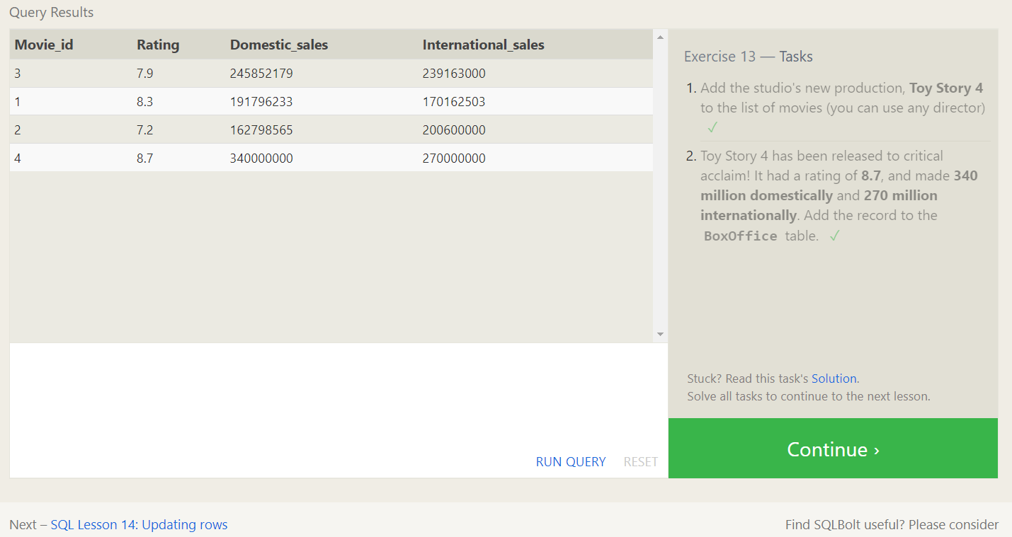

**1.INSERT INTO Movies (Title, Director, Year, Length_minutes)**

**VALUES ('Toy Story 4', 'Any Director', 2022, 0);**

**2.INSERT INTO Boxoffice (Movie_id, Rating, Domestic_sales, International_sales)**

**VALUES ((SELECT Id FROM Movies WHERE Title = 'Toy Story 4'), 8.7, 340000000, 270000000);**

# **SQL Lesson 14: Updating rows**

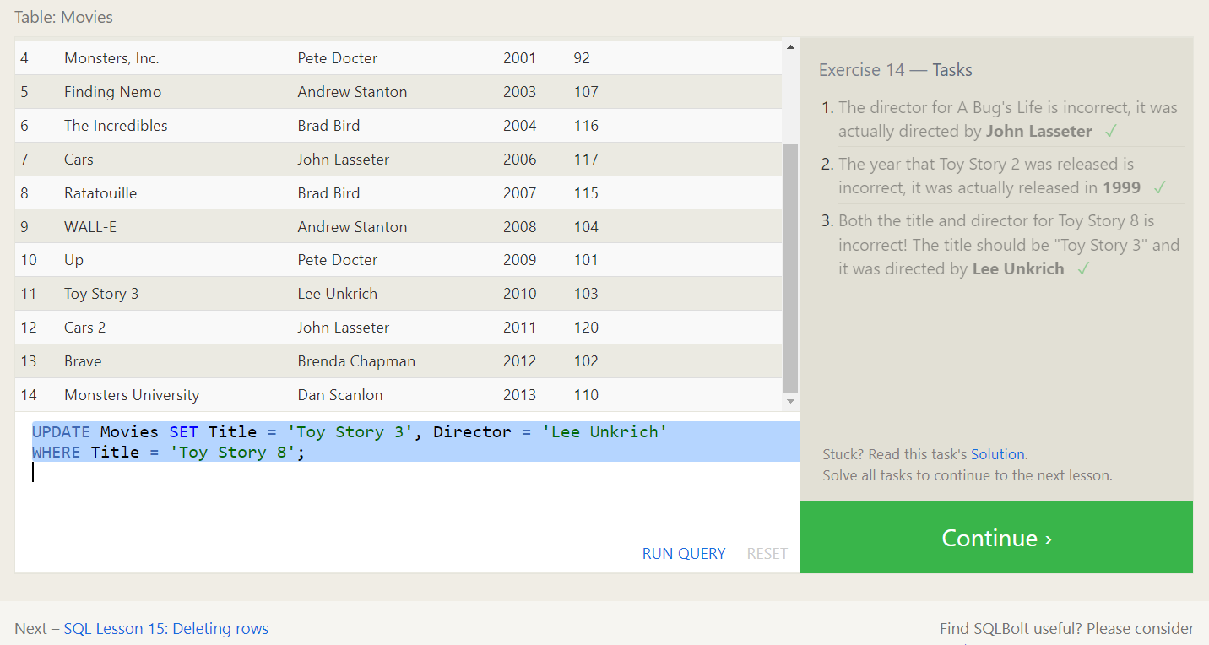

**1.UPDATE Movies SET Director = 'John Lasseter'**

**WHERE Title = 'A Bug''s Life';**

**2.UPDATE Movies SET Year = 1999 WHERE Title = 'Toy Story 2';**

**3.UPDATE Movies SET Title = 'Toy Story 3', Director = 'Lee Unkrich'**

**WHERE Title = 'Toy Story 8';**

# **SQL Lesson 15: Deleting rows**

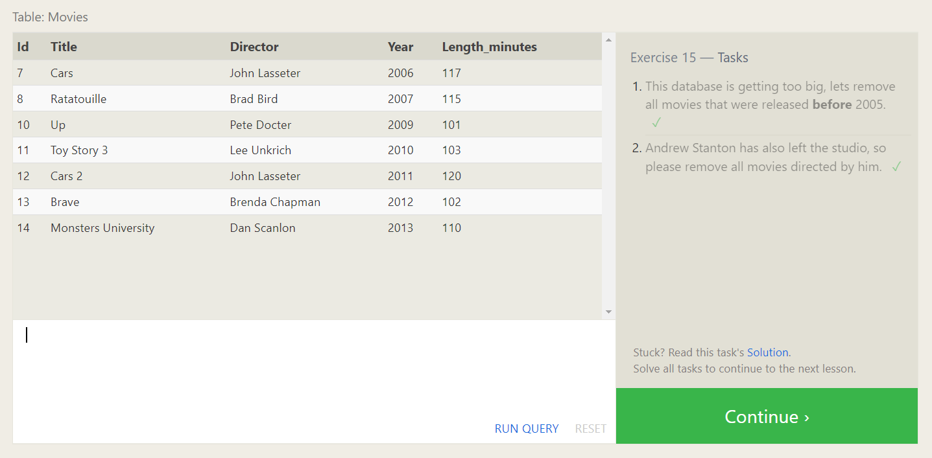

1.DELETE FROM Movies

WHERE Year < 2005;

2.DELETE FROM Movies

WHERE Director = 'Andrew Stanton';

# **SQL Lesson 16: Creating tables**

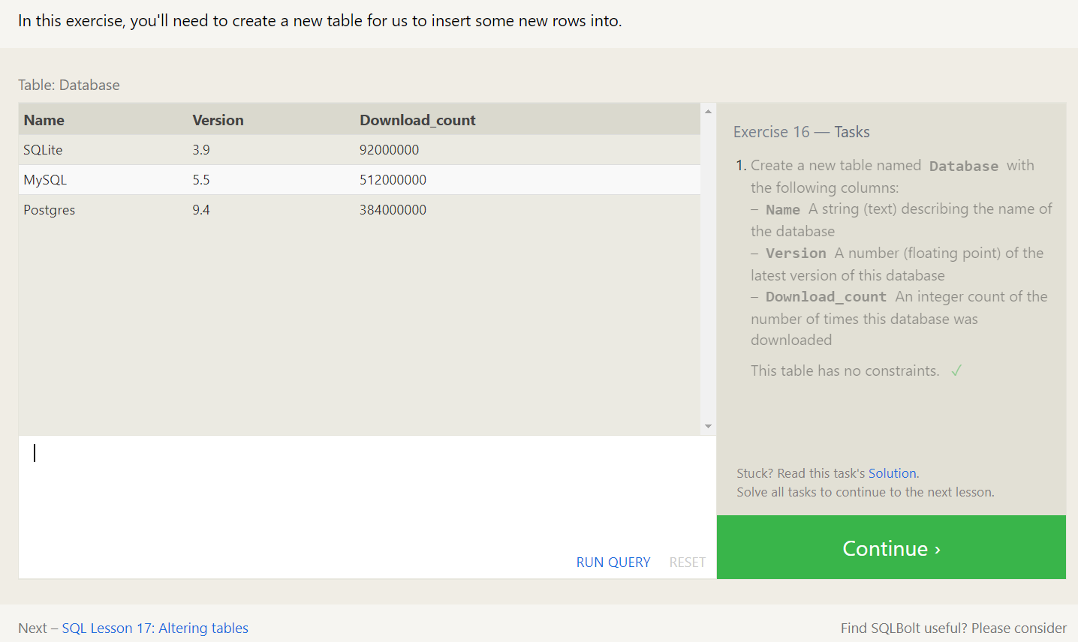

**1.CREATE TABLE Database (**

**Name TEXT,**

**Version FLOAT,**

**Download_count INT**

**);**

# **SQL Lesson 17: Altering tables**

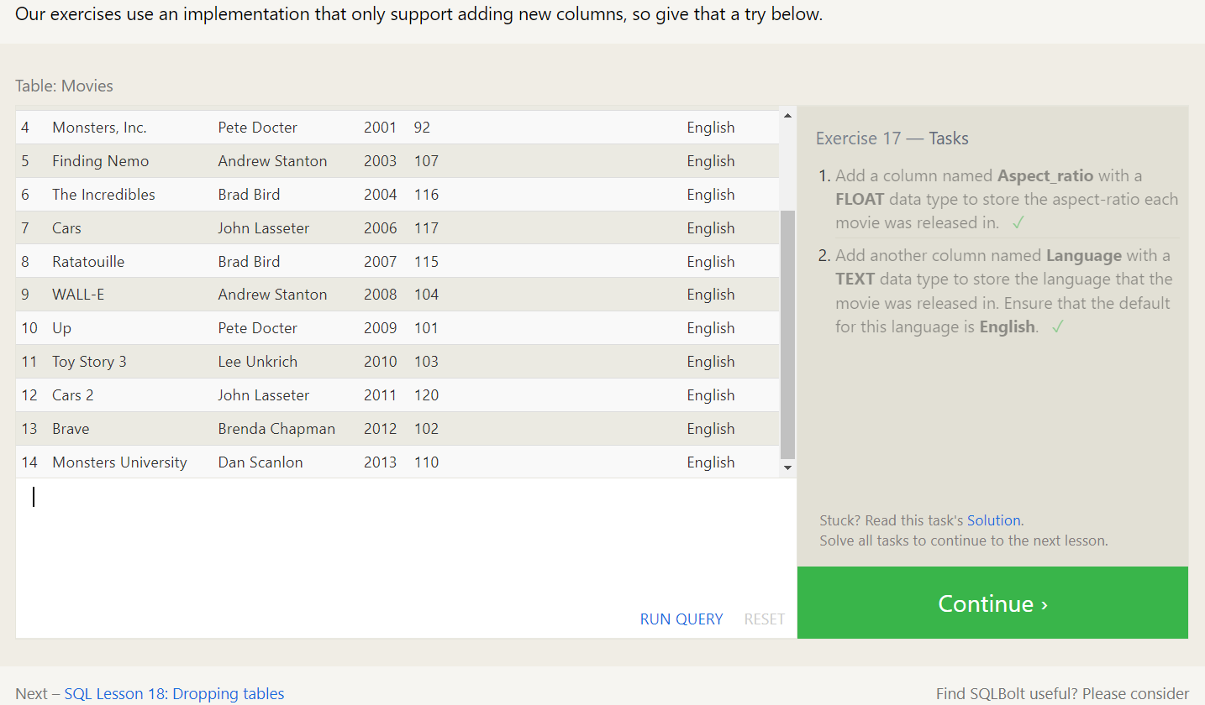

**1.ALTER TABLE Movies**

**ADD COLUMN Aspect_ratio FLOAT;**

**2.ALTER TABLE Movies**

**ADD COLUMN Language TEXT DEFAULT 'English';**

# **SQL Lesson 18: Dropping tables**

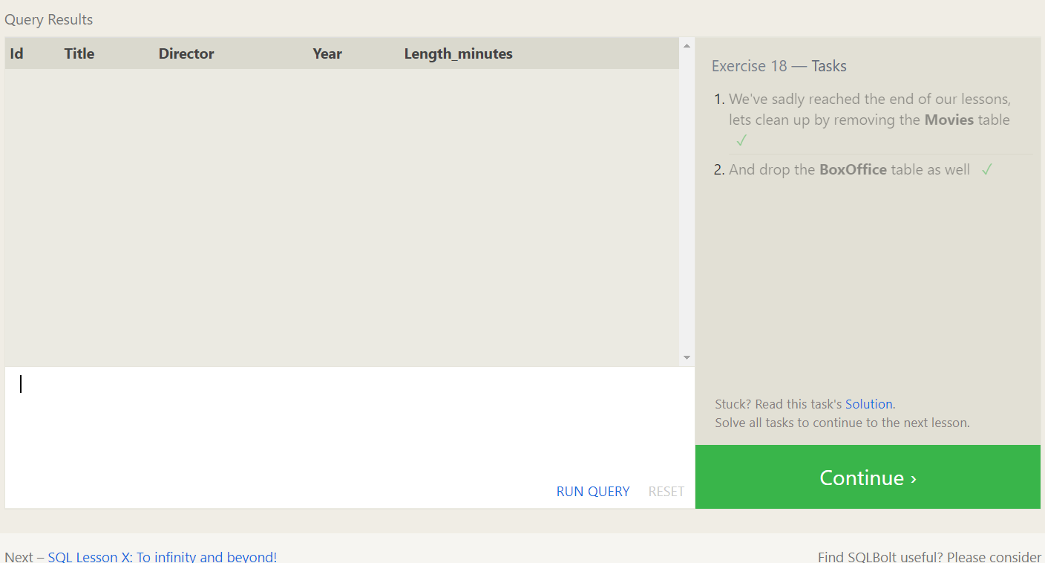

**1.DROP TABLE IF EXISTS Movies;**

**2.DROP TABLE IF EXISTS BoxOffice;**

